**PROFILING AND OPTIMIZATION**

**PROFILING 1**

To make this profile and this optimization **Glowroot** tool has been used.

Description:

A N+1 Query problema has been detected when, by loggin in as admin, a search is made for all the owners that exist in our system.

When the view of all owners (/owners) is loaded, all the owners and pets of each one appear. It has been detected that, in that view, for each pet that appears the visits of each one are loaded.

In our system we have 13 pets associated with different owners, so for each pet that we have included in our database, 13 queries are made that return the visits of each pet has.

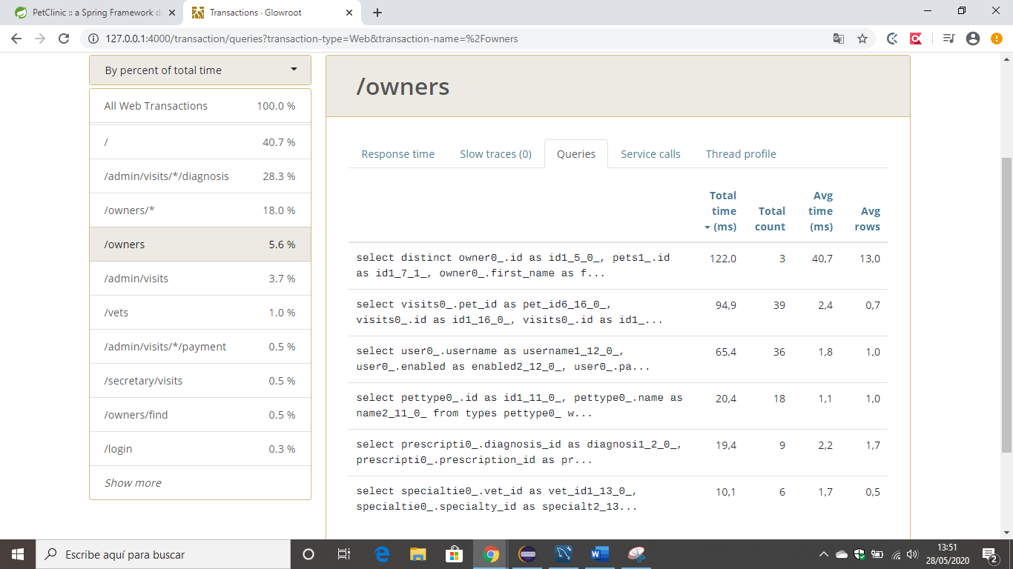

It can be seen with:

When that view is loaded once:

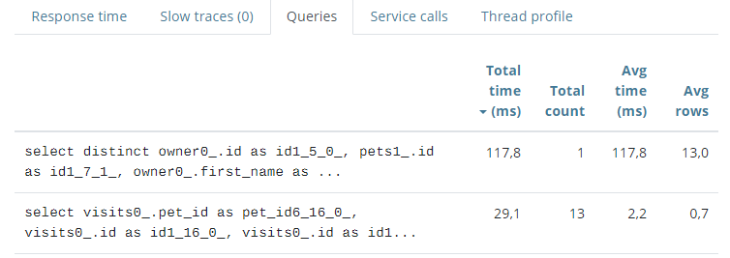

When that view is loaded twice :

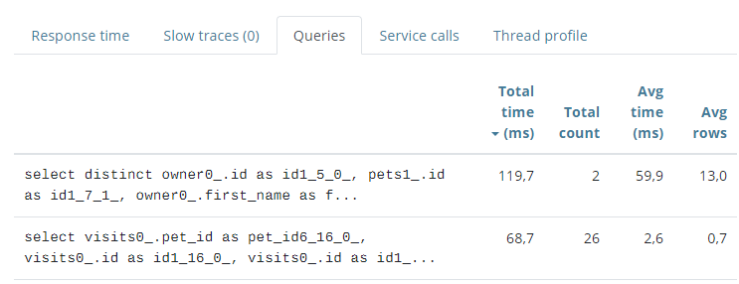

When that view is loaded three times:

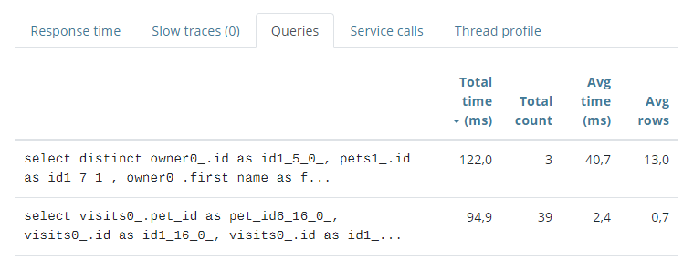

Problem:

It has been detected in the model that the relationship of pet with visits was of type **.EAGER**, wich means that whenever a pet is loaded, it’s visits are loaded.

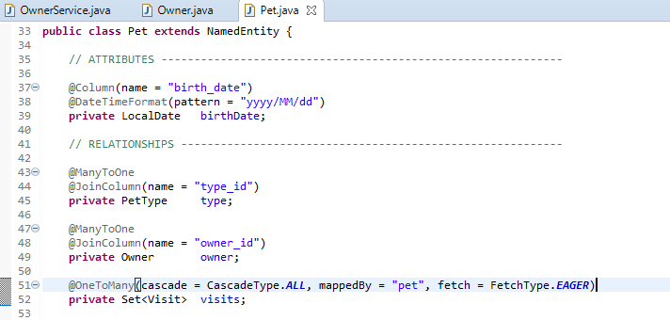

Solution:

It has been changed and noe the relationship pet-visits has been set to type .LAZY so that ii only loads when necessary (since visits is somethig we don’t need in the /owners view we are talkin about).

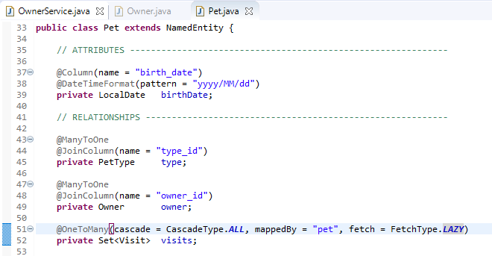

In this way, now in Glowroot you can see that those N Querys that were made for each pet in our database have disappeared.

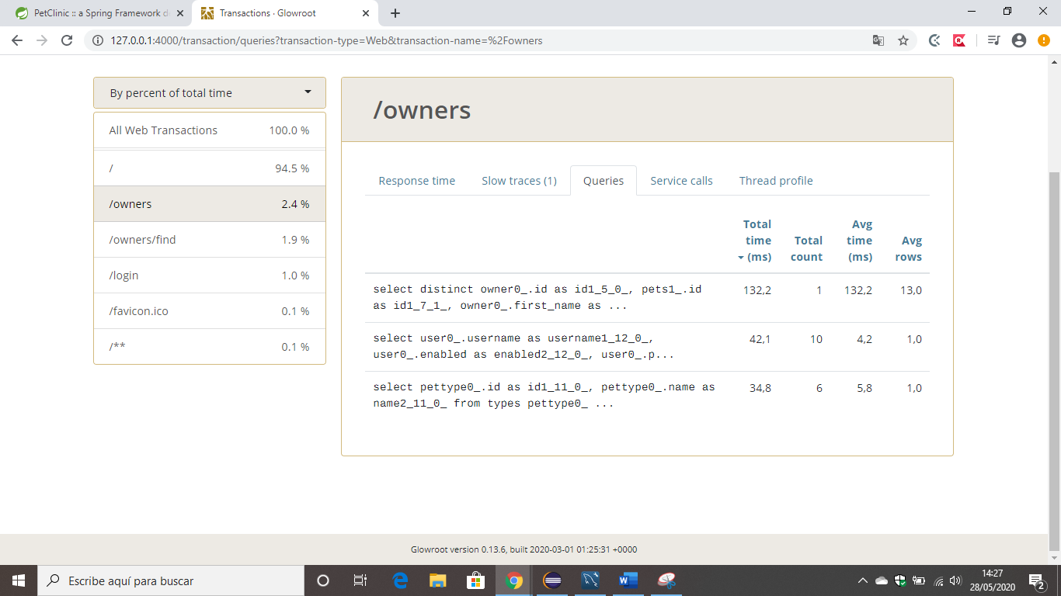

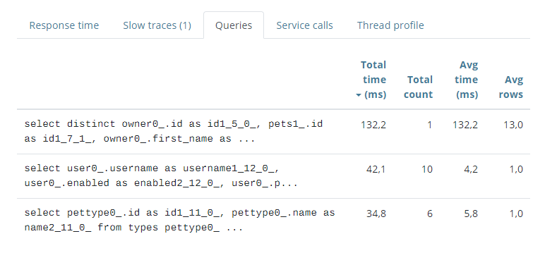

**PROFILING 2**

Description:

Aa

Problem:

Aa

Solution:

Aa

**PROFILING 3**

Description:

Aa

Problem:

Aa

Solution:

Aa